|  |  |
| --- | --- |
| Create word game with javascript | Unless your name begins with a vowel (A, E, I, O, U), 'B', 'F' or 'M' you don't  have to care about special rules. The verse for the name 'Gary' would be like this:  Gary, Gary, bo-bary Banana-fana fo-fary Fee-fi-mo-mary Gary!  At the end of every line, the name gets repeated without the first letter: Gary becomes ary . If we take (X) as the full name (Gary) and (Y) as the name without the first letter (ary) the verse would look like this:  (X), (X), bo-b(Y)  Banana-fana fo-f(Y) Fee-fi-mo-m(Y) (X)!  Vowel as first letter of the name.If you have a vowel as the first letter of your name (e.g. Earl) you do not truncate the name.  The verse looks like this:  Earl, Earl, bo-bearl Banana-fana fo-fearl Fee-fi-mo-mearl Earl!  'B', 'F' or 'M' as first letter of the name  In case of a 'B', an 'F' or an 'M' (e.g. Billy, Felix, Mary) there is a special rule.  The line which would 'rebuild' the name (e.g. bo-billy) is sang without the first letter of the name.  The verse for the name Billy looks like this:  Billy, Billy, bo-illy |

E009

Dhrumil Burad

MWA Assignment 1

Banana-fana fo-filly Fee-fi-mo-milly Billy!

For the name 'Felix', this would be right:

Felix, Felix, bo-belix Banana-fana fo-elix Fee-fi-mo-melix Felix!

Task to be done

1. Create a html page with a text field to enter name
2. Write javascript code to create name game

**Source Code:**

<!DOCTYPE html>

<html lang="en">

<head>

    <meta charset="UTF-8">

    <meta http-equiv="X-UA-Compatible" content="IE=edge">

    <meta name="viewport" content="width=device-width, initial-scale=1.0">

    <title>Document</title>

    <script>

        function retrieve() {

            var x = document.getElementById("word").value;

            console.log(x)

            if (!["a", "e", "i", "o", "u", "b", "f", "m"].includes(x[0].toLowerCase())) {

                document.getElementById("para").innerHTML = "Result is ";

                document.getElementById("para").innerHTML += `<br>${x}, ${x}, bo-b${x.slice(1, x.length)}<br>Banana-fana fo-f${x.slice(1, x.length)}<br>Fee-fi-mo-m${x.slice(1, x.length)}<br>${x}!`;

            }

            else if (["a", "e", "i", "o", "u"].includes(x[0].toLowerCase())) {

                console.log("vow")

                document.getElementById("para").innerHTML = "Result is ";

                document.getElementById("para").innerHTML += `<br>${x}, ${x}, bo-b${x.toLowerCase()}<br>Banana-fana fo-f${x}<br>Fee-fi-mo-m${x}<br>${x}!`;

            }

            else if (["b"].includes(x[0].toLowerCase())) {

                document.getElementById("para").innerHTML = "Result is ";

                document.getElementById("para").innerHTML += `<br>${x}, ${x}, bo-${x.slice(1, x.length)}<br>Banana-fana fo-f${x.slice(1, x.length)}<br>Fee-fi-mo-m${x.slice(1, x.length)}<br>${x}!`;

                console.log("bfm")

            }

            else if (["f"].includes(x[0].toLowerCase())) {

                document.getElementById("para").innerHTML = "Result is ";

                document.getElementById("para").innerHTML += `<br>${x}, ${x}, bo-b${x.slice(1, x.length)}<br>Banana-fana fo-${x.slice(1, x.length)}<br>Fee-fi-mo-m${x.slice(1, x.length)}<br>${x}!`;

                console.log("bfm")

            }

            else if (["m"].includes(x[0].toLowerCase())) {

                document.getElementById("para").innerHTML = "Result is ";

                document.getElementById("para").innerHTML += `<br>${x}, ${x}, bo-b${x.slice(1, x.length)}<br>Banana-fana fo-f${x.slice(1, x.length)}<br>Fee-fi-mo-${x.slice(1, x.length)}<br>${x}!`;

                console.log("bfm")

            }

        }

    </script>

</head>

<body>

    Enter No <input type="text" id="word">

    <input type="submit" onclick="retrieve()">

    <p id="para">Result is </p>

</body>

</html>

**Screenshots:**

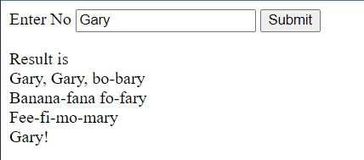

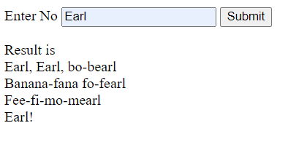

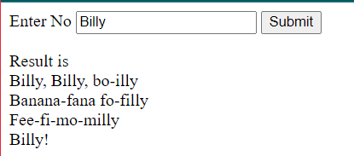

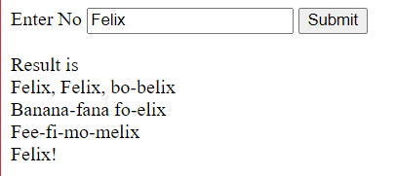

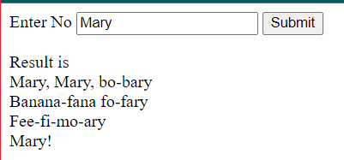

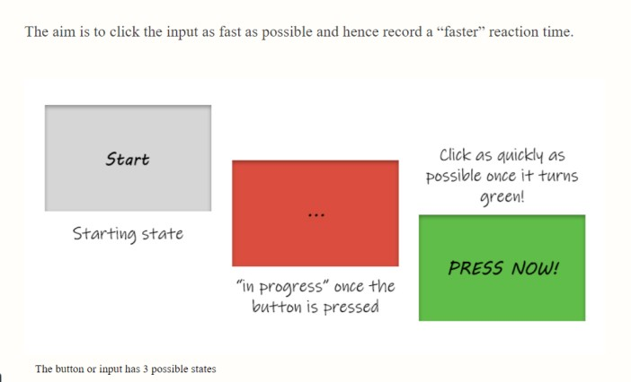**2.Write javascript code to create following event**

**Source Code:**

<!DOCTYPE html>

<html lang="en">

<head>

    <meta charset="UTF-8">

    <meta http-equiv="X-UA-Compatible" content="IE=edge">

    <meta name="viewport" content="width=device-width, initial-scale=1.0">

    <title>Asignment 1 Q2</title>

    <style>

        #star {

            border: 1px solid black;

            width: 15%;

            height: 150px;

            font-size: 29px;

            font-weight: bold;

            margin-top: 150px;

            margin-left: 50px;

            background-color: blanchedalmond;

            font-family: 'Courier New', Courier, monospace;

        }

        #h {

            margin-left: 450px;

        }

    </style>

    <script>

        let startTime;

        function start() {

            document.getElementById("star").style.marginLeft = "350px";

            document.getElementById("star").style.marginTop = "200px";

            document.getElementById("star").style.backgroundColor = "red";

            document.getElementById("para").innerHTML = "....";

            let delay = (Math.random() * 8) * 1000

            console.log(delay)

            setTimeout(

                function () {

                    document.getElementById("star").style.backgroundColor = "green";

                    document.getElementById("star").style.marginLeft = "450px";

                    document.getElementById("star").style.marginTop = "200px";

                    document.getElementById("para").innerHTML = "Press Now";

                    document.getElementById("star").onclick = press;

                }, delay);

        }

        function press() {

            document.getElementById("h").innerHTML += "\nPRESSED"

            console.log("PRESSED")

        }

    </script>

</head>

<body>

    <button onclick="start()" id="star">

        <p id="para">Start</p>

    </button>

    <h1 id="h"></h1>

</body>

</html>

**Screenshots:**

